Creating Microservices for account and loan

For Accont:

Code

AccountController.java

package com.cognizant.account.controller;  
  
import org.springframework.web.bind.annotation.*;  
  
import java.util.Map;  
import java.util.Random;  
  
@RestController  
@RequestMapping("/accounts")  
public class AccountController {  
  
 private final Random random = new Random();  
  
 @GetMapping("/{number}")  
 public Map<String, Object> getAccount(@PathVariable String number) {  
 int balance = 10000 + random.nextInt(900000); // Generates a balance between 10,000 and 909,999  
 return Map.*of*(  
 "number", number,  
 "type", "savings",  
 "balance", balance  
 );  
 }  
}

Output:

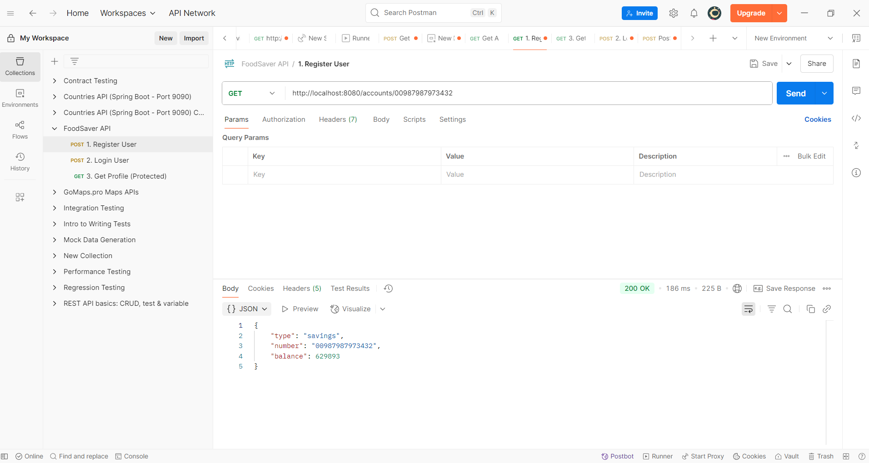

For Loan Microservices:

Code:

package com.cognizant.loan.controller;  
  
import org.springframework.web.bind.annotation.*;  
  
import java.util.Map;  
import java.util.Random;  
  
@RestController  
@RequestMapping("/loans")  
public class LoanController {  
  
 private final Random random = new Random();  
  
 private final String[] loanTypes = {"car", "home", "personal"};  
  
 @GetMapping("/{number}")  
 public Map<String, Object> getLoan(@PathVariable String number) {  
 String type = loanTypes[random.nextInt(loanTypes.length)];  
 int loanAmount = 100_000 + random.nextInt(901_000); // 100000 to 1000000  
 int emi = 1_000 + random.nextInt(9_001); // 1000 to 10000  
 int tenure = 6 + random.nextInt(55); // 6 to 60 months  
  
 return Map.*of*(  
 "number", number,  
 "type", type,  
 "loan", loanAmount,  
 "emi", emi,  
 "tenure", tenure  
 );  
 }  
}

Output:

Output for both open simultaneously:

